**Principles of Data Science (5530-0001)-Assignment 1**

**Name: Ankitha Srirama Reddy**

**ID: 16355578**

**1. Answer:**

Stage 1 – Data collection:

Data is gathered and saved in an appropriate format at this stage.

**Folder structure:**

* Acquired the data and put it in a.csv file so that the analysis could be done.
* README.txt file contains the metadata about the dataset.

Stage 2 – Data Processing:

Here, gathered data will be transformed so that it is ready for analysis.

* Preprocessing of data is performed using the scripts.

* After the data is initially fed into the script, several preparation operations are carried out, such as renaming the columns with appropriate names and converting the categorical values to numerical values to make them more useful for analysis. Checked to see whether any records contain NA occurrences. And the final, clean data that was gathered and was prepared for analysis is kept in a separate file.

**Folder Structure:**

**Stage 3 – Data Analysis:**

* To determine the pattern of relationships between the fields of the dataset, data analysis is carried out by running the scripts.

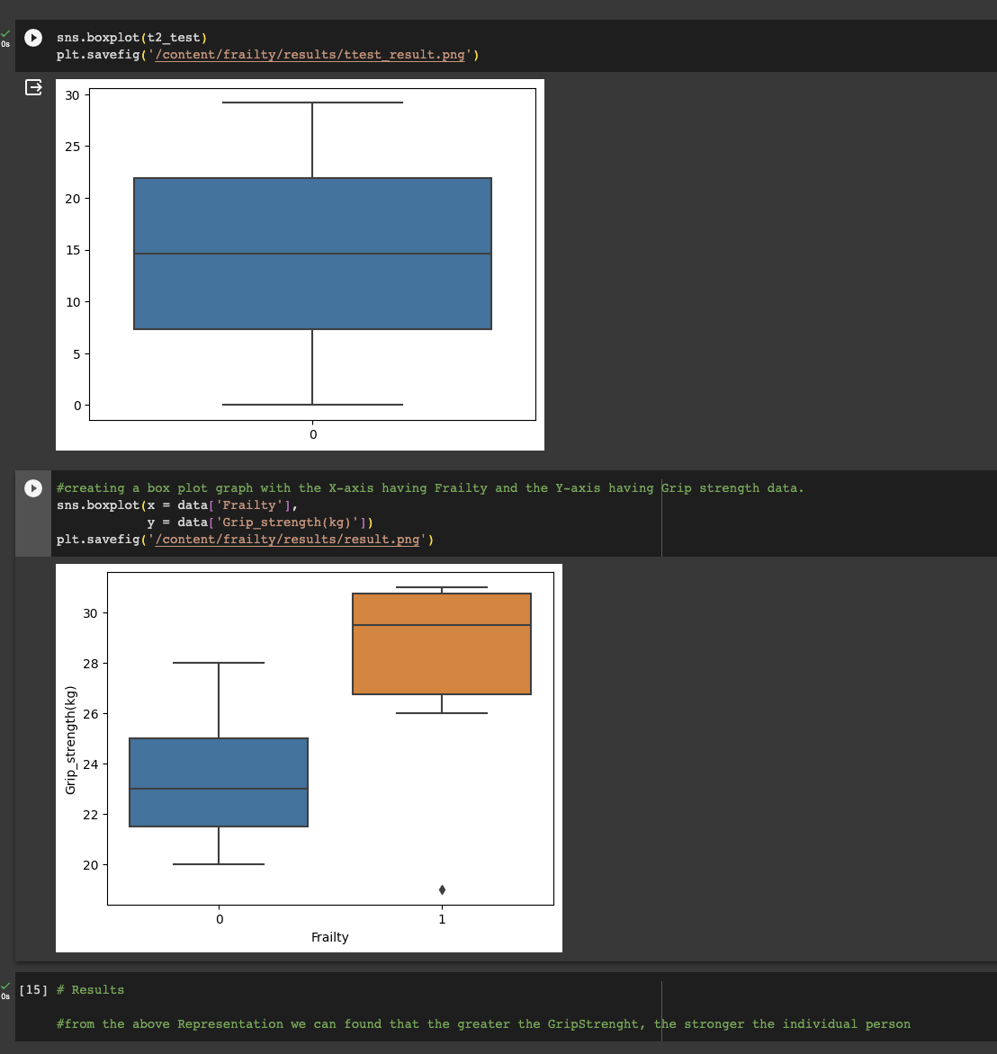

* At this level, analysis is done on the cleaned, processed data.
* The findings of a two sample t-test investigation between weight and frailty are plotted below:

* A box plot graph is created with data on grip strength on the Y-axis and frailty on the X-axis.

**Analysis Result:** The box plot illustration makes it abundantly evident that a person will be stronger if their grip strength is greater.

**Folder Structure:**

